# Lectures

RES – renewable energy sources

EEG - German: Erneuerbare-Energien-​Gesetz

EEG Levy – налог на EEG

## Power Basics

### 6 types of energy:

|  |  |
| --- | --- |
| Chemical energy | Stored energy released as the result of 2 or more atoms and/or molecules combining to form a chemical compound |
| Electrical energy | Energy associated with the flow of electrons  This course is focusing on the electric energy |
| Electromagnetic energy | Energy associated with electromagnetic radiation including visible light, infrared and ultraviolet light, x-rays, microwaves, radio waves, and gamma rays |
| Mechanical energy | Energy that can be used to raise a weight |
| Nuclear energy | Stored energy released as a result of particles interacting with or within an atomic nucleus |
| Therman energy | Energy associated with atomic and molecular vibrations that result in heat |

### What is electricity

Electricity is a flow of electrons through a conductor

|  |  |  |
| --- | --- | --- |
| Atom |  |  |
| Electricity |  | Conductors - materials that readily conduct electric current |
| Ohm's Law | If the road is tiny – cars get stuck  Higher voltage (road) means you can transport more energy (cars). | Current (Ampere -A): the rate at which electrons flow through a conductor  Voltage (Volt –V): the force (potential difference) that moves electrons  Resistance (Ohm –Ω): degree by which materials oppose to electric current |

### Electricity can be produced from various energy sources using different processes

|  |  |  |  |
| --- | --- | --- | --- |
| Energy source | Principle | Process | Examples |
| Chemical energy | Electrolyze  Electrons are transferred between materials | * Electrodes interact with electrolyte, leading to   + One electrode with excessive negative charge   + One electrode with excessive positive charge * When connecting the 2 poles via a conductor, the imbalance in charge creates an electric flow | Batteries |
| Electromagnetic energy | Magnets  Electrons are pushed by changing magnetic fields | * Electromagnetic induction is used to generate electrical power   + A turbine spins a shaft connected to a coil   + Coil is suspended between the poles of a magnet and connected to a circuit by metallic brushes * Due to the magnetic field' electrons flow through the coil and brushes into the electric circuit | Electric generator |
| Sunlight  Photons move electrons | * PV cells are made of semiconductors (i.e., silicon); silicon is transformed into an electricity conductor by adding various materials (i.e., phosphorous and boron) * When light strikes the cell, the absorbed energy (photons) determines electrons to move * Through metal contacts on the top and bottom of the PV cell, the current can be used externally | Solar PV |

### Electricity consumption = the conversion of electrical power into other types of energy

|  |  |  |  |
| --- | --- | --- | --- |
|  | Energy | Effects | Direct applicability |
| Electric energy | Mechanical energy | Magnetism | Electric motors  Moving electrons create magnetic fields. These are used to spin a shaft, which creates mechanical energy |
| Thermal energy | Heat | Incandescent light bulb  When electrons move through a filament of tungsten, this starts to glow due to the heat |
| Electro-  magnetic energy | Light | Fluorescent light bulb  Certain gases emit ultraviolet light when electrons move through them. This light than make the phosphor atoms in the incandescent tube glow |
| Electric energy | Information transfer | Transistors, chips  By controlling electricity flows, numbers 0 and 1 can be represented, and so the transmission of information in binomial form is possible |

P (Power) = U (Voltage) xI (Current)

* Power (Watt –W): amount of electricity required to perform a certain task(to move electrons through a specific device)
* Current (Ampere -A): the rate at which electrons flow through a conductor
* Voltage (Volt –V): the force that moves electrons

### Power Vs Voltage

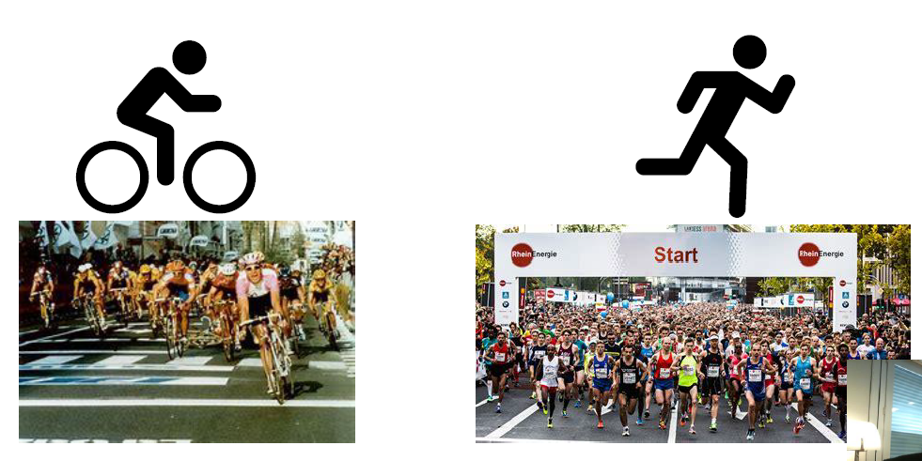

### Types of electric current

|  |  |  |  |
| --- | --- | --- | --- |
| Type of current | Power generation process (examples) | Voltage shape | Why? |
| Direct current   * Electrons flow in one direction * Direction of current does not change over time * Generated, e.g., by electrochemical or photovoltaic sources |  |  | - DC is simplier than AC |
| Alternating current   * Electrons change flow direction over time * Generated by electromagnetic power sources * Turns per minute drive frequency of electrons changing flow direction |  |  | - AC is easier to generate (Simplicity of permanent magnets alternators)  - Allows to switch between voltage levels  - Voltage can be chosen for optimum efficiency and optimum capital cost  - thus, better economy of power system operations |

Synchronous generator generates alternating current of specific frequency

* Magnetic field rotates driven by mechanical force, i.e., at 3,000 turns per minute
* Change of magnetic field over time induces voltage
* Voltage follows change of magnetic field, i.e., sinus curve
* Voltage frequency follows frequency of change of magnetic field, here rotating at 3,000 turns per minute, thereby 50 Hz

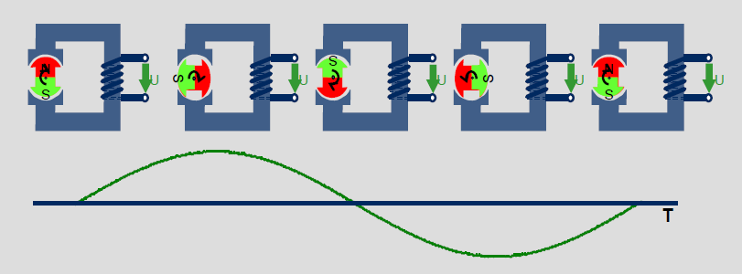

Late 1800‘s => the war of currents

* Edison (DC) vs Tesla (Westinghouse) (AC)
* Edison opened the first commercial power plane for producing DC in NY in 1892
* Tesla who was hired by George Westing house believed that AC was superior
* Tesla was right, but Edison never gave up

### 3-phase current is generated in most power plants

|  |  |  |
| --- | --- | --- |
| Type of current | Power generation process (examples) | Voltage shape |
| Alternating current |  |  |
| 3-phase current:   * 3 alternating systems, each shifted 120º on a circle * Current output of systems also shifted by 120° each |  |  |

### Work of a transformer

Transformers - are electrical devices used to change the voltage level of an electrical current

|  |  |
| --- | --- |
| Electricity properties | Principle |
| 1. There is magnetism around an electric circuit  2. Whenever a magnetic field changes, a current appears | P(power) = U(Voltage) x I(Current), N = np. of wires     * Electricity at high voltage is run through a number of wires around an iron core * Alternating current leads to an alternating magnetism in the core * The changing magnetism creates current in the neighbouring wires * The lower number of wires leads to a lower voltage |

### It is more efficient to transport electricity at **super high voltages**

|  |  |
| --- | --- |
| P (Power; W) = U (Voltage) x I (Current)  The current (I)depends on and is limited by the conductor's features | To transport a higher power through a given conductor, one needs to increase the voltage |
| P (Power; W) = U (Voltage; V) x I (Current; A)  I (current) = U (Voltage) / R (Resistance) | P (Power) = U^2 (Voltage) / R (Resistance)  By doubling the voltage, a 4 times higher power can be transmitted through the same given conductor |
| Relationship between transmission loss generated by the current flowing through a conductor and the material's resistance  ΔU (Voltage loss) = I x R | By keeping a lower current, the transmission loss can be reduced, making the process more efficient |

### 4 key physical properties make electricity a unique commodity

|  |  |  |
| --- | --- | --- |
| Electricity can hardly be stored | * The flow of electrons is not "consumed" as usual commodities, it is just the movement of the particles that powers on various electrical equipment * The only way to store electricity is to "prepare" a flow at a later point in time; this is not simple to do * Electrical systems require continuous input of energy to keep electrons moving | An electrical system requires continuous surveillance and adjustment to assure that supply matches demand in real time |
| The path followed by electricity is difficult to follow | * Electrons follow the path of least resistance (i.e., it would flow through a wet tree to the ground if its branches touched the transmission line) | Interconnected utilities must cooperate and coordinate operations, as the actions of one may cause electrons to flow into/out of the others' system |
| Disturbances are quickly transmitted and hard to isolate | * The electricity flow on electrical lines moves at the speed of light (300 million meters/second) * Disturbances travel just as quick and go fast throughout the whole interconnected system * Isolating a disturbance could be done only by breaking the circuit | System operators must be prepared to react almost instantly to outages and variations in supply and demand |
| Significant voltage or frequency fluctuations are not acceptable | * The voltage and frequency levels have to be kept almost constant, to protect the units in the electricity delivery system * Electric devices don't tolerate fluctuations in voltage or frequency | The coordination has to be done with little margin for error |

### Units of demand/capacity

Demand= instantaneous amount of work required to perform the desired function

Capacity= instantaneous ability to provide energy/power required to do work

Energy= capacity required to do work multiplied by the period of time used

Usage= demand of electricity multiplied by the period of time when electricity is required to perform a specific function Units

|  |  |
| --- | --- |
| * Watt (W) * Kilowatt (kW) * Megawatt (MW) * Gigawatt (GW)   Watt hours (Wh)   * Kilowatt hours (kWh) * Megawatt hours (MWh) * Gigawatt hours (GWh) | 1 kW =1,000 W  1 MW= 1,000 kW  1 GW= 1,000 MW  1 kWh = 1,000 Wh  1 MWh= 1,000 kWh  1 GWh= 1,000 MWh |

|  |  |
| --- | --- |
|  |  |

## Basics for Power value chain

|  |  |
| --- | --- |
| Utilities historically have been integrated across upstream and downstream functions in electric power … Graphical user interface, application  Description automatically generated  Upstream: generation  Downstream: Transmission & Distribution |  |

### Utility restructuring has "unbundled" the electric power value chain and deregulated many activities

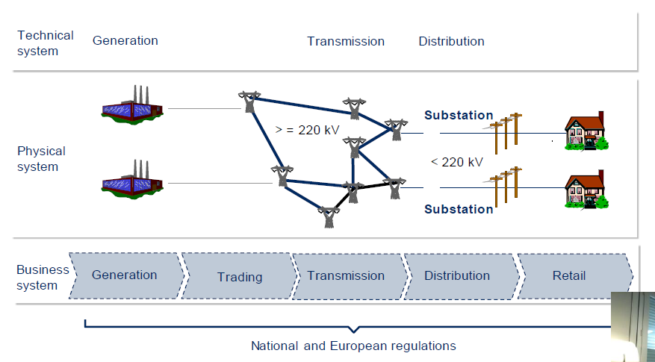

## Generation / Trading / Transmission / Distribution / Retail

The electrical delivery system is a large circuit

|  |  |  |  |  |  |
| --- | --- | --- | --- | --- | --- |
| Stage | Task | Players | Key activities | Challenges | Types / Commodities |
| Generation | Building and operating a portfolio of power plants to convert fuel into electricity | * Former integrated utilities * Independent power producers (IPPs) | * Planning of power plant portfolio (where, when, type, size, ownership) * Plant development and engineering * Operations * Maintenance | * Environment protection and emissions trading * Decentralization of power generation * Nuclear discussion * Cost pressure | * Biomaserkraftwerk * Gaskraftwerk * Kernkraftwerk * Solarenergie * Wind * Wasserpumspeicherkraftwerk |
| Trading | Optimization of risk return ratio | * Power generators * Banks * Fuel suppliers * Power retailers | * Fuel sourcing * Asset-backed trading * Proprietary trading * Structured products/origination | * Geographical flexibility (physical vs. financial markets) * Time flexibility (spot vs. forward markets) * Volatility of prices * New commodities (i.e., weather derivatives) * Origination/new structured products | Commodities:  Transfer capacities  Power  Gas  Oil  Coal co2  Ancillary services |
| Transmission | Transport of electricity on super-high voltage grid | National or regional transmission system operators (TSOs) | * Asset management * Network development * Operations and maintenance * Tariff-setting | * Cost pressure * Facilitate expanding trading * Integrating fluctuating output of renewables-based technologies * Geographical expansion of the synchronized system * Level of unbundling | *Length of transmission network in Italy is 60000 km.* |
| Distribution | Transport of electricity on super-high voltage grid | Regional or local distribution system operators (DSOs) | * Asset management * Network development * Operations and maintenance * Tariff-setting * Metering (sometimes) | * Cost pressure * Decentralized generation * Unbundling * Demographical shift * Energy efficiency * Smart Grid / Metering | Distribution power grid (DSO) consist of the following elements:   * High voltage distribution * Transmission substation * Power plant * Medium voltage distribution * Distribution substation * Low voltage distribution   Energy transition is and will be happening essentially at the **DSO-level** |
| Retail | * Sales of electricity to end customers * Billing and customer requests/handling | * Various types of companies | * Electricity sourcing * Customer acquisition * Pricing * Customer service * Account management * Metering and billing * Marketing | * Price pressure * Market opening * Development of individualized products for business and industrial customers * Energy efficiency * Smart Metering | Customer segments   * Industrial customers * Business customers * Residential customers |

### Generation

First power plant was built in 1882.

To serve population of 1 million households one power plant is needed. To serve the same amount of people you need 650 wind power plants.

### Trading

|  |  |
| --- | --- |
|  |  |

Two important **processes should be provided with continuity and high quality in the supply of electric power**:

* ensuring physical flows of electricity (provided by the power grid)
* electricity trading (wholesale and retail market) in the form of commercial transactions

Electricity trading markets:

|  |  |  |  |
| --- | --- | --- | --- |
| Forward market | Day ahead market | Intraday market | Balancing market |
| Nasdaq energy products, EPAD, FTR-optins | The trade closes on the previous day at 13.00 (CET) | The trade closes an hour before the operational hour | Submission of orders 45 minutes before the operational hour |
| Electricity trading risk hedging instruments | * Participant submits price proposal for transactions which will be next day. | * Participants can submit requests and proposals for transactions on the current day, not later than one hour before the operation hour. | * Transactions not only for commercial interest, but also to ensure system balance |

### Distribution

What does the term unbundling refer to and why did this process happen?

* When the companies were vertically integrated, they would cover the whole classical value chain of Generation-Transmission-Distribution.
* This led to monopolies; therefore, regulations were introduced to split up the operators.
* This was done to enhance market competition + implement equal opportunities for all participants

Distribution is responsible for quality of electricity supply

* complex business with a new customer orientation:
  + energy partners & differentiated needs by segment.

Smart Grid

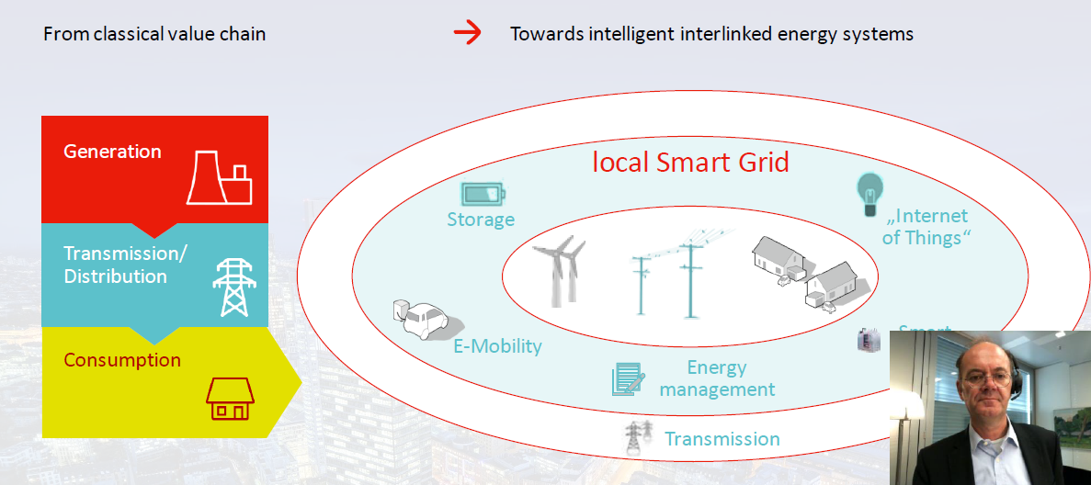

### Why and how does the energy transition affect distribution system operators?

Energy transition is happening essentially at the DSO-level.

Therefore, it affects distribution system operators by

* further decentralization and fragmentation (from the companies covering whole classical value chain).
* local rebalancing is also required.
* Increasing system responsibility

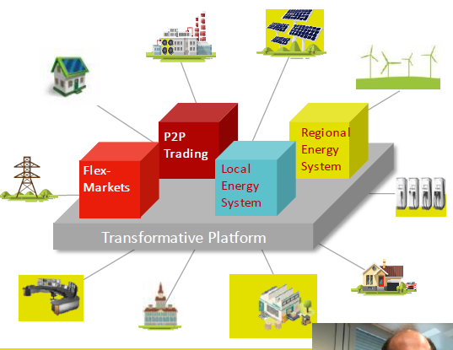

#### Is the EU successfully tackling energy transition?

* On the one hand results are good, increase in GDP of 61% while decreasing CO2 by 23%
  + Europe also has strong increase in wind/solar power consumption.
* On the other goals are not met

#### Sectors



### Retail

B2C customer significantly increase their engagement, request new solutions and seamless digital journeys:

1. (pre-service) Choosing E.ON
2. (service) Coming to X
3. (service) Well served at X
4. (service) Staying with X
5. (post-service) Leaving X
6. (post-service) Coming back to X

### Energy consumption in Germany

Every German consumes 20 kilowatt-hours (kWh) of electricity each day

* How much electricity consumes a Chinese on average compared to a German? -> ½
* How much electricity consumes an American on average compared to a German? -> 2 x

|  |  |
| --- | --- |
|  | Energy consumption in the household   |

#### German households pay the second highest electricity prices in the EU. Why is that and what problems do evolve and how could you tackle them?

* The amount of taxes and levies has increased by 40%; 55% of the electricity price can be accounted to regulatory charges.
  + E.g., households have to pay the EEG levy to extent RES energy production.
* One major problem is that high electricity prices lead to a competitive advantage for fossil energy carriers
  + Heating with fossil becomes cheaper than using electricity, although the decarbonization progress in electricity production is quite high
* Therefore, the charges should be reduced e.g. by paying them from federal budget or earnings of higher CO2 prices

### How does the electricity industry change?

It changes from system-centric, fossil-fuel and nuclear, large-scale, central towards, having global/regional perspective

=> To green & clean technologies, smaller-scale, decentralized with local proximity, sustainable, customer-centric.

## Energy Economics

### Merit-order-effect definition

Merit order

* Way of ordering available energy sources, especially electric generation, based on an ascending order of price (which may reflect the order of their short-run marginal cost of production) along with the amount of energy to be produced.
* In centralized management, the ranking works that
  + First activated stations with the lowest marginal costs to meet demand
  + Last the stations with the highest marginal costs are activated to set the market price.

This minimizes the cost of generating electricity.

Sometimes generating plants must be started out of turn because of transmission congestion, system reliability, or other reasons.

### Schematic cost curve in Industry –and structure of costs

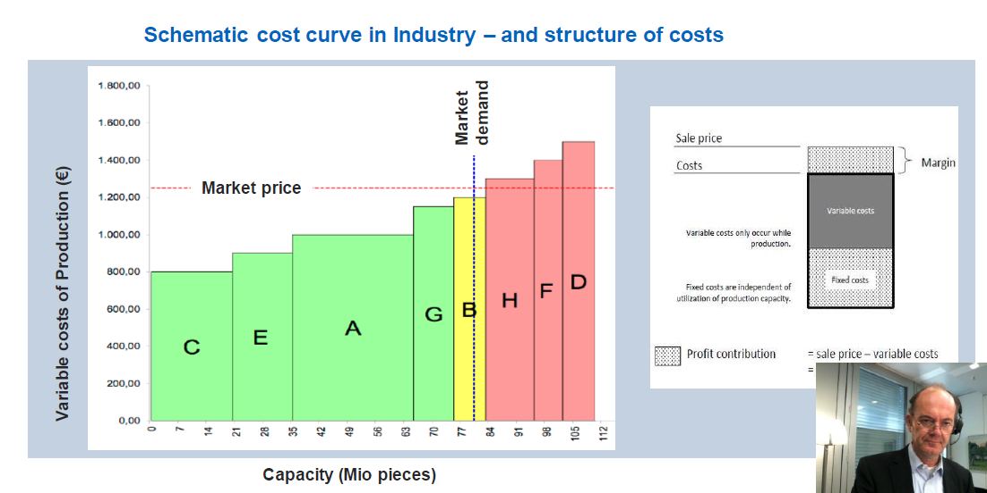

## Merit-order-effect on power prices

|  |  |
| --- | --- |
|  |  |

Merit-order-effect on power prices –

Renewables change the game for conventional



Renewable energy sources are:

* Biomass or bio-**energy**, the **energy** from organic matter for thousands of years, ever since people started burning wood to cook food. ...
* Biogas. ...
* Tidal **Energy**. ...
* Wind **Energy**. ...
* Geothermal **Energy**. ...
* Radiant **Energy**. ...
* Hydro Electricity. ...
* Compressed Natural Gas.

Security of supply–still delivered by conventional

|  |  |
| --- | --- |
|  |  |

### Difficult to predict…: Gas-Renaissance 2019

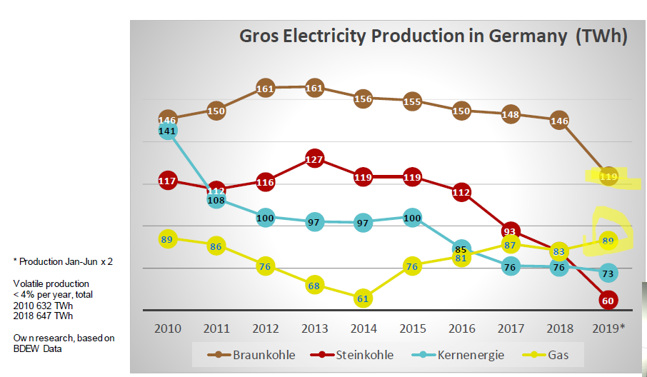

### Price-duration curve baseline 2030 for Germany

|  |  |
| --- | --- |
|  |  |
| Baseline: Significant amount of zero price hours in 2030 but most of the time (over 90%) thermal plants will be setting the price (i.e., above 0€) | E-Mobility: Flexible charging E-vehicles will lead to increasing prices in the lower part of the price-duration curve |
|  |  |
| PV: Increasing capacity leads to an increase in zero price hours (especially during early afternoon in summer) | Wind: High wind build out affects average hours much stronger than PV |
|  |  |
| Split: Zero price hours will increase in the northern zone (high RES production) and reduce in the south (demand centres) | Capacity market: Capacity market reduces peak price times |
|  |  |
| Battery: Batteries reduce peak prices but also reduce zero/low price hours |  |

## Global Resources

* Share of oil consumption declines, but gas and renewables decrease
* Primary energy: oil, gas, coal
* Hydro energy very capital intensive
* The game of oil is ending - Unconventional oil is a game changer
* Energy turnaround in the USA driven by success of unconventional gas
* Energy diversity is a question of security
* Oil process are hugely affected by different political situations
* Gas reserves are increasing dominated by Russia, Middle East
* Much more energy is consumed by the countries which have gas
* Significant drop in gas prices in Germany (if the price drops so much it can be good for environment, because some gas can be substituted with coal and its good, not too sustainable, but ok).

### In the narrow past a switch from coal to gas could be observed. Name possible influence factors, leading to that development.

The decision to switch from coal to gas could have been driven by the following factors:

* Stricter emission standards (higher costs of CO2 certificates)
* Lower natural gas prices (especially in US in 2009)

# Energy Markets, Regions& Politics

## Energy Trilemma & International Conventions

Energy Trilemma Index: essential to balance three dimensions:

* energy security – management of primary energy supply.
  + In EU: it highly depends on gas imports (Norway and Russia)
* energy equity – for poor and developing countries – manages accessibility and affordability of energy
* environmental sustainability – for developed and reach countries – reduction in energy and CO2 intensity. The best performance is northern European countries and Brazil

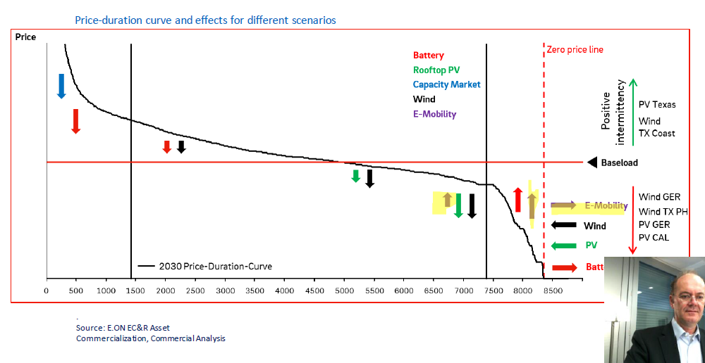

### Non-tariff measures affecting investment in Energy





### Historic climate deal in Paris

Problem of Paris agreement – it is not a legally binding agreement

#### The agreement:

195 countries adopted a new, legally binding global climate deal to keeping the increase in global average temperature to well below 2º C above pre-industrial levels

#### Commitment:

* Goal: Set more ambitious targets as required by science every 5 years-Transparency: Report to each other and the public on progress
* Progress: Global stock take every five years

#### Role of EU:

The EU has played a key role in brokering the historic agreement

Decarbonization –Carbon pricing policies are in place in 57 countries worldwide –and across Europe (in 2016)

* **Concept**: mechanism to address climate change by creating financial incentives for companies and countries to lower their emissions by switching to more efficient processes or cleaner fuels.
* **EU system of carbon pricing:** EU ETS which works on cap-and trade principle:
  + Set cap on the amount of CO2 on companies
  + Excess is allowed to trade
  + Number of carbon permits is gradually yearly reduced

## Regional Energy Markets

|  |  |
| --- | --- |
| CCPI (climate change performance index) designed to   * enhance transparency in international climate policies. * aiming is to put pressure on countries that have failed on climate protection * and to highlight countries with best practices   (CCPI 2019) |  |

# CEM Summary (20WS)

|  |  |  |  |  |  |  |  |  |  |  |  |  |  |
| --- | --- | --- | --- | --- | --- | --- | --- | --- | --- | --- | --- | --- | --- |
| Energy Physics - Basics Microscopic: Attraction force between electrons and nucleus. Electricity is generated by flow of electrons from atom to atom. Ohm’s Law: **V = IR** - Higher voltage, more energy can be transported Electrical power: **P = VI** (Unit: kW)   |  |  | | --- | --- | | Direct Current | One direction, generated by electrochemical/ photovoltaic source with constant voltage. | | Alternating Current | Magnetic field directions change over time, frequency (Hz) determines flow direction. Sinusoidal voltage.  Synchronous AC of specific frequency can transmit energy. Magnetic field rotates due to mechanical force, and voltage follows change of magnetic field.   * **Loss in Voltage = I * R.** Higher voltage > lower current, thus, reduced loss. * Doubling voltage, 4 times higher power. * **I = V / R -> P = V^2 / R** |   Transformer and power transmission   * Transforming electricity of different voltages by ratio of nos. of wires.   o **I1/I2 = V1/V2 = N1/N2** (N: #wires)   * Alternating current -> alternating magnetic field -> inducing current of neighboring wires (magnetic induction -> electrical power transmission) * Power plants use 3-phase current - 3 alternating systems shifted 120degrees on a circle, current output also shifted by 120 degrees each (1/3 sin cycle)   o Easy switch of voltage level   * Voltage from power plant is stepped up by transformer. Super high voltages during transmission. Distribution through lines of lower voltages for   buildings/homes. | Energy Physics - Why Electricity is a special commodity?  |  |  | | --- | --- | | Electricity Storage | Unlike usual commodities, electricity is  movement of particles.  Not easy to store energy for a later flow.  Production of electricity and meeting demand happen the same time.  Continuous input of energy is needed in the system, with surveillance and adjustments | | Path of electrons | Usually follow the path of least resistance  Utilities must cooperate and coordinate  operations to avoid electrons flowing out of the system | | Disturbance | At the speed of light (energy transmission).  Isolation can only be done by breaking a circuit, system need to react quickly to outages/variations | | Fluctuations are not acceptable | Electrical devices do not tolerate fluctuations of voltage/frequency.  Only little margin of error is allowed. |   Units of demand/capacity   * Demand: instantaneous amount of work, required to perform the desired function * Capacity: instantaneous ability to provide energy/power required to do work * Units: W, kW, MW, GW (x1000)   Units of energy/usage   * Energy: capacity required to do work * period of time used * Usage: demand of electricity * electricity is required to perform specific function * Units: Wh, kWh, MWh, GWh (x1000) |
| Power Value Chain Upstream (power generation) vs Downstream (Transmission/distribution)   * Fuel – Generating station – Transmission wires (>=220 kV) – Transmission substation (<220 kV) – distribution wires – customers   **Effect of Regulation:** Regulator sets monopoly franchise and the fair rate of return. Integrated utility has the obligation to serve customer, and customer needs to pay prudently the incurred costs (no choice of supplier, only one company available)   * National and European regulations apply to every part of the value chain.   **Smart Grid**: Transforming from classical value chain to interlinked energy system   * IoT, Smart Meter, Energy management, E-mobility, storage | Energy Economics Merit-order-effect: Ranking available sources of energy (esp generation) based on ascending order of price   * Ranking is important – lowest marginal costs are the first ones to be brought online to meet demand. * Dispatching generation that minimizes the cost of producing electricity * Generation out of merit order: transmission congestion, reliability etc.   Observation: Wind and solar energy have low marginal costs   * Pushes down the price -> exit of some other traditional energy generation. * However, wind + solar energy generation is very volatile. To ensure security of supply, conventional are still needed.   Timeline  Description automatically generated |
| Case of Irsching 5 Investment forced by politicians to support environmental protection, commissioning since 2010 – world record in efficiency.   * Good technology, cleaner gas power production plant * Production has almost stopped (2012), affected by insufficient carbon price. Unbalanced mix of regulation and market mechanism * Owner requests shutdown of facility due to huge losses   Denied due to system-relevant and stand-by reserve requirements, have to remain in service. What political measure would you have used to change it? **Alternative: Some general question coal vs. gas**  Gas way better than coal regarding greenhouse gas emissions and efficiency increasingly important, therefore bad process. A reasonable high CO2 price would have led to an advantage compared to other (especially coal) plants and would therefore be an appropriate measure. | Price-duration curve – baseline 2030 for Germany Base case: Significant amount of zero price hours in 2030, but most of the time thermal plants will be setting the price.   * E-mobility: increasing price (lower part of the curve) * PV: increasing capacity -> increase in zero price hours * Wind: High wind buildout -> stronger increase in 0 price hours * Geographical split: more 0 price hours in the North * Capacity market and battery reduces peak price times   Chart  Description automatically generated |

## Global Resources Trend

Global energy consumption

* Share of oil consumption declines, while gas and renewable increases.
* Gas has replaced the role of oil. Share of coal is stable, with recent drops.
* Hydroelectricity and nuclear energy have stable usage%

Geographical distribution

* Generally: Coal-based In Asia. Natural gas for Middle East
* Europe and North America has high diversity (balanced/sustainable energy generation)

o Only Europe in lead for renewable power generation (climate concerns vs import dependency?)

* Energy consumption per capita is affected by population, development, and politics (e.g., Commonwealth Soviet – modern transformation 1990s)
* Lowly industrialized region is less affected by political or financial events. Level of consumption remains stable.

CO2 emission in Germany and Europe

* Although there is a decline in CO2 emission (power industry) Germany/Europe, the global trend is not reversed and EU28 only counts for 9%

#### Germany is only accounting for 1,9% of global emissions. Why are we still in the focus of responsibility?

* Historically 4.7% of total emissions
* High emissions per capita
* We have the financial possibilities and can act as role models
* Power industry is not the only sector who is emitting CO2
* Greenhouse gases contain other gases.
  + Other uses will also emit greenhouse gases: building, transport, industrial combustions, forest/pest fire…
* Industrialization of China emits a lot of greenhouse gas

Climate change induces more risk (more extreme weather events, cyber threats, water problem) => requires more resilience

|  |  |  |  |
| --- | --- | --- | --- |
| **Resources** | **Trend of Reserves**  **Reserves-to-production ratios** | **Imports/Exports Pattern**  **Consumption** | **Price Volatility trend** |
| Oil | Strong increase of R/P in S.   * America: influenced by political burden (esp. Venezuela) Oil reserves is still growing, and OPEC dominance will decline | * Import: Europe/Asia (heavy dependence) Export: GCC/RUS * Strong consumption in North America, Saudi Arabia, Belgium and Korea (Wer hat, der hat) | Crude Oil price: huge volatility influenced by crisis in MENA MEGS. Strong correlation with  world events/geopolitical gains |
| Natural Gas | * Shrinking R/P in Middle East and Africa Consumption growth > reserves Increasing reserve, dominated by RUS/Middle East | * Synchronized production and consumption Strong consumption in N. America, Russia and Saudi Arabia (Wer hat, der hat) * LNG diversifies sources (as advantage) – * strong import increases in Europe and China | Drop in gas prices (esp. Europe in 2019) due to competition |
| Coal | * Far reaching reserves in N American (increasing) and Russia (decreasing). * Europe: fossil fuel dependence on RUS/GCC/North America * Coal reserves are shrinking | * Asia consumes its production; all other region falls. * Asia is dominant | Volatile but not as much  Drop in coal prices (esp. Europe) due to carbon emissions target |
| Nuclear | Stable consumption of nuclear power, despite public perception – state-owned company, political perspectives | | |
| Renewables | Strong increase in wind/solar power consumption in Asia Pacific, Europe and North America.  Hydroelectricity: Local game with maturity and stability, affected by politics and energy dependency. Strong growth in Asia.  Biofuels: Energy transition requires biofuel and e-fuels. Rising issue in sector decoupling. “self-cannibalization” of renewables and why would we need a new electricity market design with increasing RES shares?  * Renewables have low marginal costs * This leads to a significant reduction in electricity prices * High shares of wind a solar lead to low prices, which lead to low profits and therefore an increase in RES leads to lower profitability | | |

|  |  |  |  |  |  |  |  |  |  |
| --- | --- | --- | --- | --- | --- | --- | --- | --- | --- |
| Energy Trilemma and International Cooperation **Non-tariff measure affects all trade.** NTMs has twice the impact of tariffs on global trade.  Example: Local content requirements, government procurement, investment restrictions, legal system/intellectual property protection.  **Politics and Media Influence.** Negotiation and stance, with pressure between countries. Methodology and transparency are important. International conventions  |  |  | | --- | --- | | United Nations Framework Convention on Climate Change (UNFCCC) - established 1992 / into force 1994 | * International environmental treaty aimed at stabilizing global GHG emissions and climate system * Legally non-binding character * Signatories split into 3 groups: Annex I Annex II and developing countries | | Kyoto Protocol –establ. 1997 / into force 2005 | * Legally binding targets to reduce GHG (CO2, CH4, N2O) * Industrialized countries to reduce collective GHG emissions by 5.2% between 2008 -2012 (vs. 1990) * “Common but differentiated responsibilities” * Flexible mechanisms to reach targets * Group of several Annex I countries can create a market-within-a-market; EU is such a group * Signatories split into 2 groups: Annex B (industrialized countries) and Non-Annex B countries | | EU Emission Trading Scheme –established 01. Jan 2005 - EU ETS Directive 25. Oct. 2003 | * EU created EU ETS to reach Kyoto target * Originally independent from the UNFCCC and its Kyoto Protocol but “Linking Directive” (2004/101/EC) allows to use certain amount of Kyoto certificates from JI and CDM projects to cover emissions | | European Climate and Energy Policy | * Major pillar of EU climate policy to reach 20-20-20 targets and cut GHG emissions by one-fifth compared to 1990 by 2020 version | | Regional Outlook of Energy Trilemma/Challenges India, Asia, Middle East and Africa has highest fossil-related GDP growth with worst performance in energy. USA  * Energy equity and security are very strong over the past years. * Improving environmental perspective * Carbon emissions generally decreases, positive outlook  India  * High variance between stated and necessary (2040) * More focus on energy equity, but not very effective * Poor performance in environmental sustainability * [Poor air quality.](https://www.studydrive.net/de?utm_source=Document&utm_medium=Watermark&utm_campaign=Watermark_DE)  China  * Imbalanced situation with improvement in energy equity * Energy driver is based on coal from 1970 – 2020. * Bad performance in environmental sustainability, but more employment/capacity investment recently * Decreasing price of renewable (Merit-order curve)  Gulf States  * Oil-based economy (dominance remains), but price steering by OPEC+ is challenged by unusual drop of prices * Fossil fuels use is still growing * Poor performance in environmental sustainability, but there is more investment on renewable projects. |
| European Energy Outlook and Politics Europe has a relatively heterogeneous energy transformation, which challenges climate strategy – subsidiarity instead of unified measures.  **Power Generation: Heterogeneous landscape**  // Generally: Strongest reduction of fossil fuel and with smallest divergence with the stated situation  // Mix differs from country to country. Diversity is needed.  o Challenging climate strategy (subsidiarity > unified measures)   * Hydroelectric: Scandinavian and Alps (CH/A) - based on landform * Nuclear energy: France - affected by politics * Fossil energy: Eastern Europe especially Poland * Wind: Spain, Ireland, Germany * Solar: Germany and Ireland - sunshine hours matter * Renewable Trend: Norway producing >100%, also strong in Germany and Spain. Poor in Poland and France.  EU-wide Political Measures  * Focus on the beginning: Harmonization of market rules   + Economy grows by 61% but emission falls by 23% (1990 – 2020) * Focuses of European Energy Union: energy security (diversification), internal energy market (free flow), energy efficiency (reduce imports), decarbonization (emission trading), R&D (low-carbon tech) * EU is generally dependent on Gas imports (Norway and Russia) * 42% solid fuel, 66% gas and 88% oil are imported. * Gas flow from Russia to Central Europe (North Stream / 2) * Gas helps diversifying energy source, but subject to politics and international trade stability * Juncker-COM: Target 2030   + Clean energy package: Renewable energies (-> 33%), energy efficiency +32.5%   + Clean mobility CO2 reduction   + Further: climate neutrality by 2050     - Net-zero by 2050 demands efforts from companies, citizens and investors * European Emission Trading System   + Focusing on emission-intensive industrial plants   + For emission lower than the threshold, the CO2 difference can be   + Sold (as certificates) in the secondary market.   + o For emission higher than the threshold, need to buy certificates   o Rewards for investing in filter/innovation/plants for less carbon  • Use of energy label for electrical appliances   * Sustainable development funds by EIB, Structural Change Fund etc. * EU Green Deal: still in progress, comprehensive strategies, with various pollution perspectives (energy, industry, building, air pollution). 2021 revision of legislation and new funding directives.   + Funding incentive scheme: leave no one behind * NECP Germanys Energy+Climate Plan 2021-30. EU-COM Assessment is not so positive…   + Power business has contributed and will meet targets, but we cannot lean back – neither as a country nor as a company  Corona and Emission • Heavy drop in CO2 emission and power consumption (-17%)  o Price of CO2 certificate drops  • Power consumption has not increased to its normal level.  • Strong decrease in heavy industrial production energy use  o Example: Financial crisis also reduces energy consumption  • New normal after corona – behaviour shifts and social norms changes  o Change of financial measures, reallocation of investments  o Possible delay of climate change programme (lack of cash) How did the corona crisis affect the Energy Markets in short term and what might be implications for the future?  * Short term significant reduction in total energy and electricity consumption * However, questionable if this will lead to a long-term effect * Many people expect “new normal”, with shifts an behaviour, change in climate policies and social agenda * Major countries want to use corona aids to enhance energy transition | EnergiewendeGeneral concept  * 3 pillars: exit from nuclear, supply security, climate protection * Germany is strong on trilemma assessment by WEC (#9)   o 40% of energy is from sustainable source in 2020,  exceeding target (35%).  o Germany still has a high energy consumption per capita Exit From Nuclear Energy  * Affected by constitutional decisions based on phase-out   agreements (first started in 2000) progress and Fukushima accident   * All nuclear energy plants will be closed by 2022. * However, there are still many nuclear power plants near German border (especially Belgium and France)   o Lack of solidarity leads to confusion Renewable energy and its debate  * Energiewende is driven by addition of renewables (solar and wind, hydro remains stable)   o Mostly replacing hard coal and nuclear   * Dramatic increase in installations over the country   o Decentralized, scattered with strong infrastructure  o Distance of wind power plants from other structures  o Requires financial and entrepreneurial commitment  o Politicians need to be persuaded for implementation  o Society: NIMBY   * Wind+Solar production is unreliable and volatile   o As much as 3 to 55 GW   * Electricity across Germany is not homogeneous, more fossil fuels in NRW and Sachsen   o New generation centres are far from load centres  o E.g. Südlink: requires many new network lines Some regions are particularly hit very hard by system change. Potential of RES (esp. wind) significantly higher in the **north of Germany**, therefore enormous grid extension necessary which have low acceptance in population. High costs for bottleneck management and curtailments. Also “Not in my backyard” problem for wind, 10H rule etc. **Maybe also sth. about decentralization or emerging storage technologies**  **Reduced CO2 Emission**   * Stark decrease of CO2 emission in 2019, due to sudden increase of CO2 emission certificates price (but then after corona things change) * Gas renaissance in 2019 * Key sectors: Power, Industrial, Transport, building, agriculture * Affordability of electricity – Germany customers are paying for * Energiewende (energy prices are expensive)   o Taxes and levies increased by 400%.  **Long-term Outlook**   * 50% in 2030, 65% in 2040, 80% in 2040. * Actions needed in political and individually level   o Behaviour and responsibility (e.g., e-mobility)   * International consultation and tangible agreements are crucial (measures as role model – sustainability is important)   o Energiewende as a global example   * Sector coupling for reliable decisions   o Ensuring both economic growth and climate protection   * Indirect measures can be more effective (e.g., CO2 price) |

|  |  |  |  |  |  |  |  |
| --- | --- | --- | --- | --- | --- | --- | --- |
| Case Study of Georgsmarienhütte – Steel Industry **Overview**   * Highly competitive market * Steel production is a carbon-intense industry. * From the regional perspective: China is the biggest dominating region from production and consumption almost with their own rules. * Steel plant needs approximately as much energy as Berlin * Steel production in Germany is very small, however, if steel producer goes to China from Germany, the standard will get lower.   **Georgsmarienhütte**   * GMH group portfolio was cut down from 35 (2016) -> 25 (2018), modernizing and transformation.   + If the portfolio is too wide, minor projects may take up resources for developing core strengths * Global operations with 7000 employees, 54 locations * They have a modern site and use scrap for this   **Energy management of GMH Group**   * Steel is continuous cycle of production – scrapping – processing – reutilizing * Use of scrapped steel reduces ecological footprint * Energy management concept of GMH: achieve exemption from EEG tariffs, while maintaining an economic production of steel in Germany. * Achieving energy efficiency and cost saving at the same time  Typical examples of energy management to secure efficiency:  * + - * Reducing compressed air consumption through technical measures (e.g., regular check, analysis of system pressure)       * Reducing water use by adjusting cooling requirements and anti-freezing in winter depending on outside temperature       * Reducing electricity consumption – reduced by optimizing the lighting       * Reducing of gas consumption through waste heat recovery - waste heat from e-furnace to generate steam -> using heat directly at the location.       * Using CO2 to produce storage gases  Trends in steel production / consumption  * Recycling – steel production from scrap metal is effective raw material recycling  Competition drives efficiency  * Energy efficiency accelerates, along with steady uptake of renewable sources of energy. * Example:   + ThyssenKrupp Carbon2Chem – turning carbon into valuable     - * H2 (Water electrolysis) + Syngas (gas cleaning)       * = Methanol (cars)       * = Ammonia (agricultural) * Potential of expanding renewable energies in Germany   + hurdles of authorities, politics, and society (“not in my backyard”)   + import of renewable energy will be mandatory   + not to stop energy transition, but to make it in the proper way – and to implement on reasonable and transparent way * Chemical product can be used as energy storage   + Top gases as a link of cross industrial network   + This cycle will allow the emissions from the process in the steel and chemical production to use this gas – the steel mill gas – 150 x gasometers  Hydrogen path  |  |  | | --- | --- | | Dark hydrogen | Existing industrial process, associated with CO2 emissions | | Blue hydrogen | From natural gas, for medium term and climate neutrality | | Green hydrogen | From electrolysis and renewable energies, climate neutral but only a long-term solution  For neutrality, it requires a lot of green hydrogen. |   However, we do not have it is still very expensive and we hardly have enough renewable energy, and we better use it for power consumptions and not transform it with efficiency losses to hydrogen.  As long as we can exchange fossil fuels with renewable energy its better.   * Should we only shy away in Germany and only ask for green hydrogen, knowing that we can not afford it right now? * Why not going for blue hydrogen for transformation period and avoid grey hydrogen (which if purely currently used). Other countries like Japan, Korea are doing it this way. Then we would be able to reduce our carbon footprint to use the blue hydrogen and to help the hydrogen market to get to scale, get to the competitive market and then, in a decade transform slowly to green hydrogen. * (how it is done now is – we accept that we keep with the grey (the worst) only because we want best – is not really smart and is not the best and not the honest approach for the hydrogen strategy so far) * European hydrogen strategy recently published is a bit smarter  Case of Outokumpu (Finland)  * High-quality stainless steel through – sustainability leader in the steel industry.   + Have the lowest carbon footprint   + Ferrochrome production with minimized carbon footprint   + High energy efficiency with recycled materials   + Digital manufacturing for cost competitiveness   + Carbon-neutral electricity source (e.g., replacing propane with LNG) * Stainless steel production of Outokumpu is 10 times more CO2 efficient than the production in Indonesia      * We are not only emitting CO2, but we are importing it, and if this is subsidized – its absolutely wrong. 30% of the steel in Europe is imported from Asia => carbon boarder adjustement  European steel industry measures to prevent carbon leakage  * Electricity taxation (competitiveness and availability of low carbon energy) * Trade policy (emission trading system and border adjustment (tariff / duty)) * EU CO2 emission trading system (secure adequate compensation to companies in carbon leakage industries) * Carbon border adjustment (global carbon duty/ tariff to ensure level playing field).  Coal makes no money Hambach Forest: Germany's sluggish coal phaseout sparks anger   * In the past everything was about increasing the efficiency   Another confirmation that profitability of coal is on decline: <https://www.exponentialview.co/evs-charts-of-the-week-25/>   Wind turbines  * Have grown | Case Study of E.ON – Strategic Spin-offs and MergersReason of transformation  * Because energy industry focuses on green and clean technologies. * Therefore E.ON does transform as small-scale, distributed and customer centric:   + Offering easy and digital solutions (e.g. getting quote in 30 seconds online, digital energy storage)   + Offering holistic, connected solutions with digital energy management   + Solutions for e-mobility (guaranteed green electricity, home power box, smart tariffs, charging at home & workplace)  Strategic actions companies have taken to react on the transition of energy markets (overall)  * Restructuring company, split of company amongst market sections * Creating subsidiary, focusing on future aspects * Restructuring industry Merging/split up of fields with competitor  New E.ON for new energy world  * + Renewable – distribution – sales/customer solutions    New Uniper for conventional energy world  * + Central power generation, transmission, global commodity market (Upstream focus)   + Provide security of energy supply, system-centric   Consideration of a split   * + Technical: financial, legal issues, antitrust, pensions.   + Perspective: new culture, storytelling, human factors   + Process and operations: BAU, avoid self-absorption   Spin-off has created values, evidenced by share prices Strategy comparison with RWE Group  * Sold its downstream activity and spun-off Innogy * New RWE Group: Conventional power, trading/gas midstream * New Innogy: grids, retail, renewables * RWE still holds 76.8% of Innogy. 23.2% for other shareholders.  Democratization of energy world  * Decarbonization through deep electrification – increase electricity demand (grid investment and green electricity), while reducing total energy demand (efficiency) * Decentralization: Core energy infrastructure – grid network – innovative solutions  E.ON and RWE groups (2018)  * Innovative assets exchange * E.ON acquires RWE stake on Innogy (>90% shareholding – merger squeeze out), and RWE has 16.67% stake on E.ON * Net cash payment from RWE to E.ON * Provide cash offer to existing minority shareholders * Deal closing transfer of renewable assets, nuclear minority participation and gas storage assets   Graphical user interface  Description automatically generated New E.ON focus after strategic moves  * Energy Networks (Internet of Energy) * Customer solutions (assistance in business transformation, sustainable energy solutions for commercial/households) * Carbon-neutral goal in 2040 |
| Customer Service of E.ON  * Core segments: Consumers/small businesses, industrial customers, cities/municipalities * Presence in 15 European countries (Central/Eastern Europe focused)   **Customer Engagement and Solutions**   * Promoters (happy/loyal) – Passives (neutral) – Detractors (unhappy/-ve) * Digitalization for value creation – 24/7 global reach, lower marginal costs, customer value as data for modelling, business growth   + Digital customer experience – products, journeys, operations etc.   + Guiding customers using AI (consumption -> tariff selections etc) * Customers -> players/prosumers (decentralization moves)   + Commercial power storage for households drives profitability of rooftop solutions (EV cost is lower)   + PV roof system * Continuous B2C proposition with innovative solutions (e.g. Solar Cloud) * Energy home for connected energy solutions at household level   **E-mobility**   * Technological factor: higher reach, shorter charging time, better network * Regulatory push (funding, diesel prohibition) * Higher customer preferences – [better selection](https://www.studydrive.net/de?utm_source=Document&utm_medium=Watermark&utm_campaign=Watermark_DE) * E.ON provides all-in-one package for households with eMobility * E.ON provides commercial solutions for retailers (e.g. fast charging stations)   **Complex Energy Systems Management**   * Single/multi-site solutions, B2B solutions, sustainable buildings… * Energy optimization using AI (predictive analysis, root cause, bottleneck.)   **Example of energy solution for buildings and development**   * Heating and cooling supply through local distribution * Utilization of CHP waste heat for cooling * Groundwater heat pump for cooling and heating * Heat pump operation and e-mobility supply through PV and CHP power * Peak loads covered by district heating (local heat network) * Ensure low share of combustion processes in heating | Energy Networks as Digital Services Energy system is becoming more complex:   * Both unidirectional and bidirectional power flows * Smart grid transformation * Energy infrastructure solutions (Design – Build – Operate) Flexible Load balancing -> AI-based real-time production, bottleneck management, flex platform * Disaggregation (algorithm), Smart Home, Network Zone balance (prediction of deficits), Energy optimization * Disaggregation example: household – washing machine <-> needs for new washing machines / ordering suggestions |
| Global Agenda for Future **New decade of customer**   * More willing: energy efficient appliances, air conditioning, insulation * Less willing: smaller screens for televisions / computers **Energy Scenarios and forecasting** * Energy transition is a part of wider grand transition (not only about energy) * Relying on quant modelling and better forecasting for transition is fatal  Types of scenarios:  1. Plausible scenario  * Assumptions (stories) -> Plausible futures  1. Outlook  * Quantitative model (conditional projection projection) -> best/ baseline/ worst case * Demands tend to be higher  1. Normative scenario  * Capabilities/values -> preferred future and gap * Demands have more variance  Similarities in Forecasts  * Dynamics and diversity of energy system (social complexity) * Growing importance of globally coordinated action and policies * Although fossil fuels remain important in energy mix, there is a rapid growth in acceleration of electrification * Shifting competition in diversification in energy mix * Role of government, integration, cooperation, and investment   New developments required   * Regional demographic diversity, alternative storage pathways increase * Wider sustainability, well-living agenda * Digitalization shifts power from supply to demand side * Geopolitics of oil and manufacturing -> new patterns   Shifting social norms, new customer behaviours, environmental feedback  Carbon cost of growth:   |  |  |  | | --- | --- | --- | |  | Low economic growth | High economic growth | | High emission | Failure | Economy-driven future | | Low emissions | Environmentally driven future | Success | | Pathways to 2040 (WEC)Three plausible scenarios of modern development:  1. Modern Jazz => high success  * Digital, disruptive, agile world * Dominant market mechanisms, energy + service * Data dominance  1. Unfinished Symphony => high success  * Strong policy, long-term planning, united action for climate * Co-benefits and synergies * More hydrogen production for building/mobility use (development of national hydrogen strategies) * Lowest growth in energy per capita, highest drop of carbon  1. Hard Rock => low success  * Fragmented world, low global cooperation * National and energy security focus * Globally connected challenge. * Highest increase in energy per capita, stable carbon emission   **Pre-determined factors**   * Slow growth of population, appreciating planetary boundary * New technologies and shift of economic power to Asia (growth in primary energy use)   **Critical uncertainties**   * Pace of innovation and productivity gains * International governance and geopolitical changes * Priority given to climate change and other issues * Policy tools in action  Critical Uncertainties / Covid amplified uncertainties across all categories  * Economic trends – short term economic challenges * Cyber security risks * Hydrogen * Climate Change Management * Investor environment – uncertainty on investment * Energy supply * Carbon abatement |

After exam questions:

1. Why is there a negative correlation between the RES-share and the price? How can you explain it?